Step-by-Step: Creating a Standard Operating Procedure
Download the SOP Template here.

You are a busy business owner. Taking time to work ON your business instead of IN it is tough.

But what would happen if you were sick in the hospital? Would your team be able to function without you?

Most business owners can’t say yes to that questions. Here is a simple way to get your first three SOPs created this week so you can start to understand how to create and use them.

- Think of the last 5 problems you had to handle in your business. How many times have you repeated those issues? Make a list of issues that keep coming up over and over again in your business.

- _________________________________________________________________
- _________________________________________________________________
- _________________________________________________________________
- _________________________________________________________________
- _________________________________________________________________

Here are a few examples:
- You showed up for a meeting and they had the wrong time zone in their calendar.
- Your blog post didn’t go out when you wanted it to.

- Rank your list of most important problems. Which ones come up most often and cause the most problems?
____________________________________________________________________________________________________________________________________________________________________________________________________________________________________

- Pick the TOP priority issue to work on your first SOP.
____________________________________________________________________________________________________________________________________________________________________________________________________________________________________

- Visualize the process:

If you are a visual person map out the process on a whiteboard or piece of paper. You want to make sure you have all of the right steps in order and also figure out if certain steps can be done in tandem or not.

You probably already have the start of a procedure that you normally do. But you want to figure out as many nuances as you can think of in the process - ask yourself these questions as you are mapping it out.

- What needs to happen first?
- Who else might need to be notified?
- What passwords are needed for access?
- What software is needed to complete this?
- What visuals/videos are needed in this process?

After it’s mostly outlined:

- Is there an easier way to do this? (better software? Faster communication? Templates to use?)
- Can we eliminate/automate any steps?
- What will save money?
- How can we put more power in the hands of the employee? (can we tell them to solve problems if it costs less than $100?)

- Prep everything!

- Download the SOP Template here.
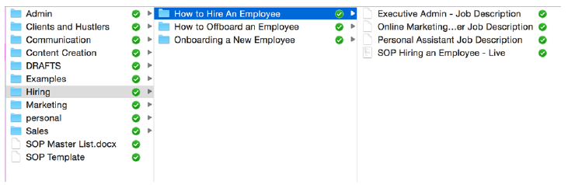

- Set up a Dropbox or Google docs folder structure

Here is a starting list to help if you have issues:

- Scheduling
- Travel
- Client onboarding
- Client off-boarding
- Passwords
- Content Creation (blog posts, podcasts, editorial calendar, etc.)
- Hiring
- Onboarding new employees
- Sending emails to your list
- Weekly business metrics
- Customer service emails
- Technical issues

Resources:

- Jing
- Dropbox
- Google Docs

